**ETL Design for Policy Group KDR Table:**

1. **Job_KDR_10_Land_And_Unlaod_Eclipse**

**Data Flow Name:** DF_KDR_Land_Eclipse

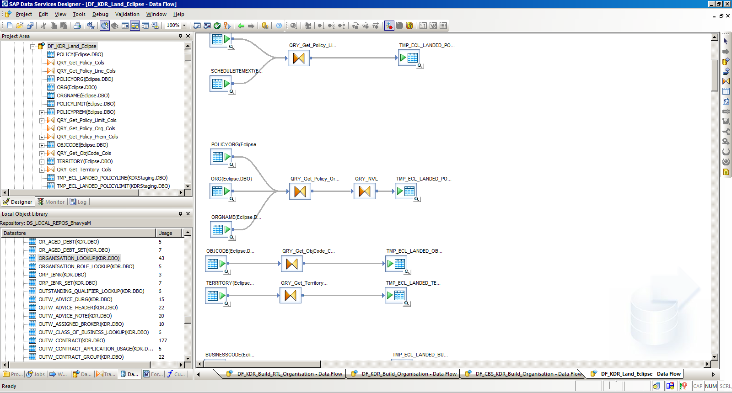

In this DF, From **PolicyOrg** table drag missing columns to destination table: TMP_ECL_LANDED_POLICY_ORG table.

Missing Columns are: OrgOrder in the destination table

1. **Job_KDR_11_Build_Reference_And_KDR_For_Eclipse**

* **Data Flow Name:** DF_KDR_Build_RTL_Inw_Contract_Policy

Once the data is loaded into TMP_RTL_KDR_Inw_Contract table,

Add a dataflow to load the RTL table for PolicyOrg: **TMP_RTL_KDR_Inw_Contract_Organisation.** New Data Flow Name would be:

DF_KDR_Build_RTL_Inw_Contract_Organisation

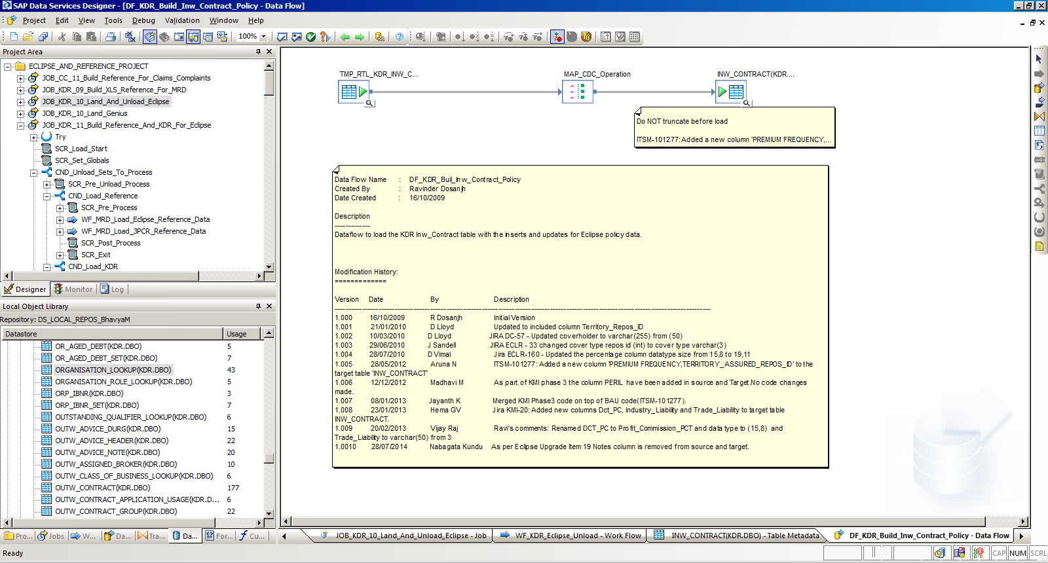

**Source Tables**: TMP_ECL_LANDED_POLICY_ORG, Organization_Lookup

**Transforms Used:** Query Transform (join, bring all default columns like Deleted_IND, Effective_Start_Dt, Policy_Org_Source_ID)

**Key_Generation_Transform:** Generate Key for Policy_Org_KDR_table

**Key_Generation_Transform:** Generate ID for Policy_Org_KDR_table

Use **Map transform** and **Query Transform** to Insert and Update the data.

**Merge transform** to merge the changes, load to new KDR RTL table: **TMP_RTL_KDR_Inw_Contract_Organisation**

Now add new data flow in the WorkFlow where Dataflow: DF_KDR_Build_Inw_Contract_Policy is mapped

New DataFlowName for Final PolicyOrg table will be **DF_KDR_Build_Inw_Contract_Organisation.**

KDR TableName for PolicyOrg would be: **Inw_Contract_Organisation**

**Inw_Contract_Organisation**

**Script:** This has run in DB**: CMS_KDR**

USE [CMS_KDR]

GO

/****** Object: Table [dbo].[Inw_Limit] Script Date: 07/08/2018 15:29:36 ******/

SET ANSI_NULLS ON

GO

SET QUOTED_IDENTIFIER ON

GO

SET ANSI_PADDING ON

GO

CREATE TABLE [dbo].[Inw_Contract_Organisation](

[Inw_Contract_Organisation_Repos_Key] [int] NOT NULL,

[Inw_Contract_Organisation_Repos_ID] [int] NOT NULL,

[Inw_Contract_Organisation_Source_ID] [varchar](50) NOT NULL,

[Data_Source_Repos_ID] [int] NOT NULL,

[Effective_Start_DT] [datetime] NOT NULL,

[Effective_End_DT] [datetime] NOT NULL,

[Current_IND] [char](1) NOT NULL,

[Deleted_IND] [char](1) NOT NULL,

[Inserted_DT] [datetime] NOT NULL,

[Last_Updated_DT] [datetime] NOT NULL,

[Load_ID] [int] NOT NULL,

[Inw_Contract_Repos_ID] [int] NOT NULL,

[Organisation_ID] [int] NOT NULL,

[Organisation_Name] NVARCHAR(255) NOT NULL,

[Organisation_Type] [varchar](30) NULL,

[LeadLine] [decimal](19, 2) NULL,

[LeaderLineInd] [char](1) NULL,

[Organisation_Order] [int] NOT NULL,

[RiskCustomerType] [nvarchar](40) NULL

CONSTRAINT [Inw_Contract_Organisation_PK] PRIMARY KEY CLUSTERED

(

[Inw_Contract_Organisation_Repos_Key] ASC

)WITH (PAD_INDEX = OFF, STATISTICS_NORECOMPUTE = OFF, IGNORE_DUP_KEY = OFF, ALLOW_ROW_LOCKS = ON, ALLOW_PAGE_LOCKS = ON) ON [PRIMARY]

) ON [PRIMARY]

GO

select * from Inw_Contract_Organisation

**Script for RTL Table for Organisation**

USE [CMS_KDR_Staging]

GO

/****** Object: Table [dbo].[TMP_RTL_KDR_INW_CONTRACT_ORGANISATION] Script Date: 08/27/2018 15:02:51 ******/

SET ANSI_NULLS ON

GO

SET QUOTED_IDENTIFIER ON

GO

SET ANSI_PADDING ON

GO

CREATE TABLE [dbo].[TMP_RTL_KDR_INW_CONTRACT_ORGANISATION](

[INW_CONTRACT_ORGANISATION_REPOS_KEY] [int] NOT NULL,

[INW_CONTRACT_ORGANISATION_REPOS_ID] [int] NULL,

[INW_CONTRACT_ORGANISATION_SOURCE_ID] [varchar](50) NULL,

[DATA_SOURCE_REPOS_ID] [int] NULL,

[EFFECTIVE_START_DT] [datetime] NULL,

[EFFECTIVE_END_DT] [datetime] NULL,

[CURRENT_IND] [varchar](1) NULL,

[DELETED_IND] [varchar](1) NULL,

[INSERTED_DT] [datetime] NULL,

[LAST_UPDATED_DT] [datetime] NULL,

[LOAD_ID] [int] NULL,

[INW_CONTRACT_REPOS_ID] [int] NULL,

[ORGANISATION_ID] [int] NOT NULL,

[ORGANISATION_NAME] [nvarchar](255) NOT NULL,

[ORGANISATION_TYPE] [varchar](30) NULL,

[ORGANISATION_COUNTRY] [nvarchar](80) NULL,

[LEADLINE] [decimal](19, 2) NULL,

[LEADERLINEIND] [char](1) NULL,

[ORGANISATION_ORDER] [int] NOT NULL,

[RISKCUSTOMERTYPE] [nvarchar](40) NULL,

CONSTRAINT [TMP_RTL_KDR_INW_CONTRACT_ORGANISATION_PK] PRIMARY KEY CLUSTERED

(

[INW_CONTRACT_ORGANISATION_REPOS_KEY] ASC

)WITH (PAD_INDEX = OFF, STATISTICS_NORECOMPUTE = OFF, IGNORE_DUP_KEY = OFF, ALLOW_ROW_LOCKS = ON, ALLOW_PAGE_LOCKS = ON) ON [PRIMARY]

) ON [PRIMARY]

GO

SET ANSI_PADDING OFF

GO

select * from [TMP_RTL_KDR_INW_CONTRACT_ORGANISATION]

**Structure of Policy_Summary:**

USE [CMS_KDR]

GO

/****** Object: Table [dbo].[Policy_Summary] Script Date: 08/21/2018 11:13:50 ******/

SET ANSI_NULLS ON

GO

SET QUOTED_IDENTIFIER ON

GO

SET ANSI_PADDING ON

GO

CREATE TABLE [dbo].[Policy_Summary](

[Policy_Key] [int] NOT NULL,

[Inw_Contract_Repos_ID] [int] NOT NULL,

[Inw_Limit_Repos_ID] [int] NOT NULL,

[Inw_Contract_Notes_Repos_ID] [int] NOT NULL,

[Inw_Contract_Organisation_Repos_ID] [int] NOT NULL,

[Territory_Repos_ID] [int] NOT NULL,

[Currency_Repos_ID] [int] NOT NULL,

[Inw_Contract_Risk_Code_Repos_ID] [int] NOT NULL,

[Settlement_Currency_Repos_ID] [int] NOT NULL,

[Broker_Contact_Repos_ID] [int] NOT NULL,

[Broker_Repos_ID] [int] NOT NULL,

[Risk_Code_Repos_ID] [int] NOT NULL,

[Underwriting_Division_Repos_ID] [int] NOT NULL,

[Syndicate_Repos_ID] [int] NOT NULL,

[PolicyID] [int] NOT NULL,

[Policy_PolicyLineReference] [varchar](50) NULL,

[Policy_ProgrammeReference] [varchar](50) NULL,

[Policy_TerritoryDesc] [varchar](50) NULL,

[Policy_UnderwriterInitials] [varchar](50) NULL,

[Policy_YearOfAccount] [int] NULL,

[Policy_ClaimIndicator] [varchar](1) NULL,

[Policy_ClaimsAgreement] [varchar](40) NULL,

[Policy_EndorsemntIndicator] [varchar](1) NULL,

[Policy_Interest] [varchar](50) NULL,

[Policy Package] [nvarchar](50) NULL,

[Policy_UniqueMarketReference] [varchar](50) NULL,

[Policy_PerilGroup] [varchar](255) NULL,

[Policy_Source] [nvarchar](50) NULL,

[Policy_SanctionStatus] [varchar](50) NULL,

[Policy_PeriodType] [varchar](50) NULL,

[Policy_Period] [varchar](5) NULL,

[PolicyPeriod_InceptionDate] [datetime] NULL,

[PolicyPeriod_ExpiryDate] [datetime] NULL,

[PolicyPeriod_FullTermInceptionDate] [datetime] NULL,

[PolicyPeriod_FullTermExpiryDate] [datetime] NULL,

[PolicyBrk_BrokerRole] [varchar](50) NULL,

[PolicyBrk_BrokerName] [varchar](50) NULL,

[PolicyBrk_BrokerPseud] [varchar](50) NULL,

[PolicyBrk_BrokerCode] [int] NOT NULL,

[PolicyOrganisation_Name] [nvarchar](255) NOT NULL,

[PolicyOrganisation_Order] [int] NOT NULL,

[PolicyLead_LloydsIndicator] [varchar](1) NULL,

[PolicyLead_LineIndicator] [varchar](1) NULL,

[PolicyLead_Line] [decimal](19, 2) NULL,

[Policy_ReportingCurrency] [varchar](3) NULL,

[PolicyOrganisation_Type] [varchar](30) NULL,

[PolicyOrganisation_Country] [nvarchar](80) NULL,

[PolicyOrganisation_RiskCustomerType] [nvarchar](30) NULL,

[Policy_RiskCode] [varchar](50) NOT NULL,

[PolicyRiskCode_Percentage] [decimal](15, 8) NULL,

[PolicyPolicyLine_ClassType] [varchar](6) NULL,

[PolicyPolicyLine_MajorClass] [varchar](6) NULL,

[PolicyPolicyLine_MinorClass] [varchar](6) NULL,

[PolicyPolicyLine_Class] [varchar](6) NULL,

[PolicyPolicyLine_LineStatus] [varchar](20) NULL,

[PolicyPolicyLine_Syndicate] [varchar](50) NOT NULL,

[PolicyPolicyLine_UnderwritingDivision] [varchar](50) NOT NULL,

[PolicyPolicyLine_SignLine] [decimal](19, 11) NULL,

[PolicyPolicyLine_SignedOrder] [decimal](10, 7) NULL,

[PolicyPolicyLine_SigningNumber] [varchar](7) NULL,

[PolicyPolicyLine_SigningDate] [datetime] NULL,

[PolicyPolicyLine_ReinsCode1] [varchar](50) NULL,

[PolicyPolicyLine_ReinsCode2] [varchar](50) NULL,

[PolicyPolicyLine_ReinsCode3] [varchar](50) NULL,

[PolicyNotes_NoteText] [varchar](4000) NULL,

[PolicyNotes_NoteUpdated_By] [varchar](50) NOT NULL,

[PolicyNotes_NoteType] [varchar](50) NULL,

[PolicyNotes_UpdatedDate] [datetime] NULL,

[PolicyPremium_SettlementCurrency] [varchar](3) NULL,

[PolicyPremium_ConsTotalClosedPrem] [decimal](19, 2) NULL,

[PolicyRpt_Currency_RateOfExchange] [decimal](18, 9) NULL,

[PolicyRpt_RateFixedIndicator] [varchar](1) NULL,

[PolicyLimit_RateOfExchange] [decimal](18, 9) NULL,

[PolicyLimit_Currency] [varchar](50) NOT NULL,

[PolicyLimit_Limit] [decimal](19, 2) NULL,

[PolicyLimit_LimitBasis] [varchar](10) NULL,

[PolicyLimit_Excess] [decimal](15, 2) NULL,

[PolicyLimit_ExcessBasis] [varchar](12) NULL,

[PolicyLimit_Narrative] [varchar](140) NULL,

[PolicyLimit_TopLimitIndicator] [varchar](1) NULL,

[PolicyLimit_ExcessIndicator] [varchar](1) NULL,

[PolicyLimit_Deductible] [decimal](19, 2) NULL,

[PolicyLimit_DeductibleBasis] [nvarchar](10) NULL,

[PolicyPolicyline_ReinsuredIndicator] [varchar](1) NULL,

[Policy_ReInsuredName] [nvarchar](255) NOT NULL,

[Policy_InsuredName] [nvarchar](255) NOT NULL,

CONSTRAINT [Inw_Contract_Summary_PK] PRIMARY KEY CLUSTERED

(

[Policy_Key] ASC

)WITH (PAD_INDEX = OFF, STATISTICS_NORECOMPUTE = OFF, IGNORE_DUP_KEY = OFF, ALLOW_ROW_LOCKS = ON, ALLOW_PAGE_LOCKS = ON) ON [PRIMARY]

) ON [PRIMARY]

GO

SET ANSI_PADDING OFF

GO

SCM_Summary table structre

USE [CMS_KDR]

GO

/****** Object: Table [dbo].[Accord_SCM_Summary] Script Date: 09/11/2018 10:35:35 ******/

SET ANSI_NULLS ON

GO

SET QUOTED_IDENTIFIER ON

GO

SET ANSI_PADDING ON

GO

CREATE TABLE [dbo].[Accord_SCM_Summary](

[Load_id] [int] NULL,

[ClaimMovement_UUId] [int] NULL,

[ClaimMovement_BrokerReference] [varchar](50) NULL,

--[ClaimMovement_ServiceProviderReference] [varchar](50) NULL, --Add it in DF

[ClaimMovement_CreationDate] [datetime] NULL, --Add in DF

[ClaimMovement_GroupReference] [varchar](18) NULL, --Add it DF

[ClaimMovement_ItemsInGroupTotal_Count] [varchar](50) NULL,

[ClaimMovement_ServiceProviderGroupReference] [varchar](50) NULL,

[ClaimMovement_ServiceProviderGroupItemsTotal_Count] [varchar](50) NULL,

[ClaimMovement_LossDescription] [text] NULL,

[ClaimMovement_MovementType] [varchar](3) NULL,

--[ClaimMovement_ClaimAmountsIndicator] [int] NULL,

--[ClaimMovement_ClaimClosedOrReopenedIndicator] [varchar](3) NULL,

[ClaimMovement_Reinsurer_Party_IdAgency] [varchar](50) NULL,

[ClaimMovement_Reinsurer_Party_Id] [varchar](9) NULL,

[ClaimMovement_Reinsurer_Party_Name] [varchar](9) NULL,

--[ClaimMovement_Insurer_Party_IdAgency] [varchar](20) NULL,

[ClaimMovement_Insurer_Party_Id] [varchar](9) NULL,

[ClaimMovement_Insurer_Party_Name] [varchar](9) NULL,

[ClaimMovement_Broker_Party_IdAgency] [varchar](20) NULL,

[ClaimMovement_Broker_Party_Id] [varchar](6) NULL,

[ClaimMovement_Broker_Party_Name] [varchar](4) NULL,

[ClaimMovement_Broker_Contact_PersonName] [varchar](200) NULL,

[ClaimMovement_Broker_Contact_Telephone] [varchar](35) NULL,

--[ClaimMovement_ServiceProvider_Party_IdAgency] [varchar](50) NULL,

--[ClaimMovement_ServiceProvider_Party_Id] [varchar](50) NULL,

--[ClaimMovement_ServiceProvider_Party_Name] [varchar](50) NULL,

[ClaimMovement_ClaimAgreementParty_Party_IdAgency] [varchar](20) NULL,

[ClaimMovement_ClaimAgreementParty_Party_Id] [varchar](3) NULL,

[ClaimMovement_ClaimAgreementParty_ParticipantFunction] [varchar](8) NULL,

--[ClaimMovement_Contract_TreatyFac] [varchar](50) NULL,

--[TechAccount_Contract_ContractNature] [varchar](50) NULL,

[ClaimMovement_Contract_BrokerReference] [varchar](17) NULL,

[ClaimMovement_Contract_ReinsurerReference] [varchar](15) NULL,

[ClaimMovement_Contract_InsurerReference] [varchar](15) NULL,

--[ClaimMovement_Contract_ServiceProviderReference] [varchar](5) NULL,

[ClaimMovement_ContractSection_ContractPeriod_StartDate] [datetime] NULL,

[ClaimMovement_ContractSection_ContractPeriod_EndDate] [datetime] NULL,

[ClaimMovement_ContractSection_ContractPeriod_UnderwritingYear] [int] NULL,

[ClaimMovement_ContractSection_PolicyPerilsConditionsDescription] [varchar](70) NULL,

--[ClaimMovement_ContractSection_ReinsurerSharePercentage_RateRateUnit] [varchar](50) NULL,

[ClaimMovement_ContractSection_ReinsurerSharePercentage_Rate] [decimal](15, 7) NULL,

--[ClaimMovement_ContractSection_InsurerSharePercentage_RateRateUnit] [varchar](50) NULL,

[ClaimMovement_ContractSection_InsurerSharePercentage_Rate] [decimal](15, 7) NULL,

--[ClaimMovement_ContractSection_BrokerSharePercentage_RateRateUnit] [varchar](50) NULL,

[ClaimMovement_ContractSection_BrokerSharePercentage_Rate] [decimal](10, 7) NULL,

[ClaimMovement_ClaimEntry_BrokerReference] [varchar](8) NULL,

[ClaimMovement_ClaimEntry_ServiceProviderReference] [varchar](18) NULL,

[ClaimMovement_Claim_BrokerReference] [varchar](18) NULL,

[ClaimMovement_Claim_ServiceProviderReference] [varchar](9) NULL,

--[ClaimMovement_Claim_BureauSigningReference] [varchar](40) NULL,

--[ClaimMovement_Claim_LossPeriodLossDateBasis] [datetime] NULL,

[ClaimMovement_Claim_LossPeriod_Description] [varchar](40) NULL,

--[ClaimMovement_Claim_LossPeriod_Description_dt] [datetime] NULL,

[ClaimMovement_Claim_LossPeriod_StartDate] [datetime] NULL,

--[ClaimMovement_Claim_LossPeriod_StartDate_dt] [datetime] NULL,

[ClaimMovement_Claim_LossPeriod_EndDate] [varchar](50) NULL,

--[ClaimMovement_Claim_LossPeriod_EndDate_dt] [datetime] NULL,

--[ClaimMovement_Claim_LossPeriod_EndDate_dt2] [datetime] NULL,

[ClaimMovement_Claim_PcsReference] [varchar](50) NULL,

[ClaimMovement_Claim_LcoCatastropheReference] [varchar](4) NULL,

[ClaimMovement_Claim_LossLocation_Location_Description] [varchar](40) NULL,

[ClaimMovement_Claim_AdjusterName] [varchar](40) NULL,

[ClaimMovement_Claim_AdjusterReference] [varchar](18) NULL,

[ClaimMovement_Claim_LawyerName] [varchar](18) NULL,

[ClaimMovement_Claim_LawyerReference] [varchar](25) NULL,

[ClaimMovement_ContractReferenceCurrency_Ccy] [varchar](3) NULL,

--[ClaimMovement_JvClassOfBusiness] [varchar](50) NULL,

--[ClaimMovement_ClaimMovementAmtItemType_G1] [varchar](50) NULL,

[ClaimMovement_ClaimMovementAmtItemAmtStatus_G1] [varchar](1) NULL,

--[ClaimMovement_ClaimMovementAmtItem_AmtShare_G1] [varchar](50) NULL,

--[ClaimMovement_ClaimMovementAmtItem_AmtCcyIndic_G1] [varchar](50) NULL,

[ClaimMovement_ClaimMovementAmtItem_AmtCcy_G1] [varchar](3) NULL,

[ClaimMovement_ClaimMovementAmtItem_Amt_G1] [decimal](19, 2) NULL,

--[ClaimMovement_ClaimMovementAmtItemType_G2] [varchar](50) NULL,

[ClaimMovement_ClaimMovementAmtItemAmtStatus_G2] [varchar](1) NULL,

--[ClaimMovement_ClaimMovementAmtItem_AmtShare_G2] [varchar](50) NULL,

--[ClaimMovement_ClaimMovementAmtItem_AmtCcyIndic_G2] [varchar](50) NULL,

[ClaimMovement_ClaimMovementAmtItem_AmtCcy_G2] [varchar](3) NULL,

[ClaimMovement_ClaimMovementAmtItem_Amt_G2] [decimal](19, 2) NULL,

--[ClaimMovement_ClaimMovementAmtItemType_G3] [varchar](50) NULL,

--[ClaimMovement_ClaimMovementAmtItemAmtStatus_G3] [varchar](50) NULL,

[ClaimMovement_ClaimMovementAmtItem_AmtShare_G3] [varchar](50) NULL,

[ClaimMovement_ClaimMovementAmtItem_AmtCcyIndic_G3] [varchar](50) NULL,

[ClaimMovement_ClaimMovementAmtItem_AmtCcy_G3] [varchar](3) NULL,

[ClaimMovement_ClaimMovementAmtItem_Amt_G3] [decimal](19, 2) NULL,

[ClaimMovement_ClaimMovementAmtItemType_G4] [varchar](50) NULL,

[ClaimMovement_ClaimMovementAmtItem_AmtShare_G4] [varchar](50) NULL,

[ClaimMovement_ClaimMovementAmtItem_AmtCcyIndic_G4] [varchar](50) NULL,

[ClaimMovement_ClaimMovementAmtItem_AmtCcy_G4] [varchar](3) NULL,

[ClaimMovement_ClaimMovementAmtItem_Amt_G4] [decimal](19, 2) NULL,

[ClaimMovement_ClaimMovementAmtItemType_G5] [varchar](50) NULL,

[ClaimMovement_ClaimMovementAmtItem_AmtShare_G5] [varchar](50) NULL,

[ClaimMovement_ClaimMovementAmtItem_AmtCcyIndic_G5] [varchar](50) NULL,

[ClaimMovement_ClaimMovementAmtItem_AmtCcy_G5] [varchar](3) NULL,

[ClaimMovement_ClaimMovementAmtItem_Amt_G5] [decimal](19, 2) NULL,

[ClaimMovement_ClaimMovementAmtItemType_G6] [varchar](50) NULL,

[ClaimMovement_ClaimMovementAmtItem_AmtShare_G6] [varchar](50) NULL,

[ClaimMovement_ClaimMovementAmtItem_AmtCcyIndic_G6] [varchar](50) NULL,

[ClaimMovement_ClaimMovementAmtItem_AmtCcy_G6] [varchar](3) NULL,

[ClaimMovement_ClaimMovementAmtItem_Amt_G6] [decimal](15, 2) NULL,

[ClaimMovement_ClaimMovementAmtItemType_G7] [varchar](50) NULL,

[ClaimMovement_ClaimMovementAmtItem_AmtShare_G7] [varchar](50) NULL,

[ClaimMovement_ClaimMovementAmtItem_AmtCcyIndic_G7] [varchar](50) NULL,

[ClaimMovement_ClaimMovementAmtItem_AmtCcy_G7] [varchar](3) NULL,

[ClaimMovement_ClaimMovementAmtItem_Amt_G7] [decimal](19, 2) NULL,

[ClaimMovement_ClaimMovementAmtItemType_G8] [varchar](50) NULL,

[ClaimMovement_ClaimMovementAmtItemAmtStatus_G8] [varchar](50) NULL,

[ClaimMovement_ClaimMovementAmtItem_AmtShare_G8] [varchar](50) NULL,

[ClaimMovement_ClaimMovementAmtItem_AmtCcyIndic_G8] [varchar](50) NULL,

[ClaimMovement_ClaimMovementAmtItem_AmtCcy_G8] [varchar](3) NULL,

[ClaimMovement_ClaimMovementAmtItem_Amt_G8] [decimal](19, 2) NULL,

[ClaimMovement_ClaimMovementAmtItemType_G9] [varchar](50) NULL,

[ClaimMovement_ClaimMovementAmtItem_AmtShare_G9] [varchar](50) NULL,

[ClaimMovement_ClaimMovementAmtItem_AmtCcyIndic_G9] [varchar](50) NULL,

[ClaimMovement_ClaimMovementAmtItem_AmtCcy_G9] [varchar](3) NULL,

[ClaimMovement_ClaimMovementAmtItem_Amt_G9] [decimal](19, 2) NULL,

[ClaimMovement_Extension_xisSCM001_xisRiskCode] [varchar](2) NULL,

[ClaimMovement_Extension_xisSCM001_xisSignedIndicator] [varchar](1) NULL,

[ClaimMovement_Extension_xisSCM001_xisBlockIndicator] [varchar](50) NULL,

[ClaimMovement_Extension_xisSCM001_xisFILCode2] [varchar](4) NULL,

[ClaimMovement_Extension_xisSCM001_xisFILMarketCode] [varchar](4) NULL,

[ClaimMovement_Extension_xisSCM001_xisTrustFundCode] [varchar](4) NULL,

[ClaimMovement_Extension_xisSCM001_xisFILCode] [varchar](4) NULL,

[ClaimMovement_Extension_xisSCM001_xisMovementReference] [varchar](8) NULL,

[ClaimMovement_Extension_xisSCM001_xisROE] [decimal](15, 8) NULL,

[ClaimMovement_Extension_xisSCM001_xisRXS] [decimal](15, 8) NULL,

[ClaimMovement_Extension_xisSCM001_xisSettlementCurrency] [varchar](3) NULL,

[ClaimMovement_Extension_xisSCM001_xisTMKIsContra] [varchar](1) NULL,

[ClaimMovement_Extension_xisSCM001_xisTMKHasContra] [varchar](1) NULL,

[ClaimMovement_Extension_xisSCM001_xisTMKIsRepl] [varchar](1) NULL,

[ClaimMovement_Extension_xisSCM001_xisTMKManualClaim] [varchar](1) NULL,

[ClaimMovement_Extension_xisSCM001_xisTMKMovementID] [varchar](50) NULL,

[ClaimMovement_Extension_xisSCM001_xisTMKEclipseClaimRefl] [varchar](50) NULL,

[ClaimMovement_Extension_xisSCM001_xisTMKTotalLossInd] [varchar](50) NULL,

[Data_fix_ind] [varchar](1) NULL,

[Created_By] [varchar](50) NULL,

[Modified_By] [varchar](50) NULL,

[Created_Date] [date] NULL,

[Modified_Date] [date] NULL

) ON [PRIMARY] TEXTIMAGE_ON [PRIMARY]

GO

SET ANSI_PADDING OFF

GO